The Canvassing Board of Morgan County has determined that after reviewing all ballots cast, including provisional ballots, the number of write-in votes cast for each particular office is not greater than or equal to the difference between the two candidates receiving the greatest number of votes and therefore no write-in votes will be itemized.
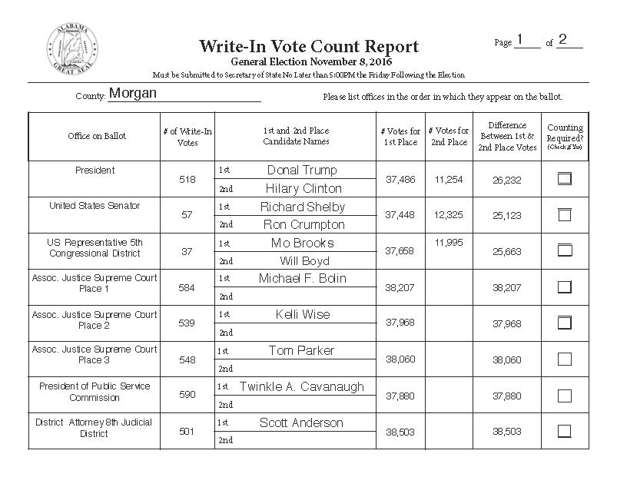
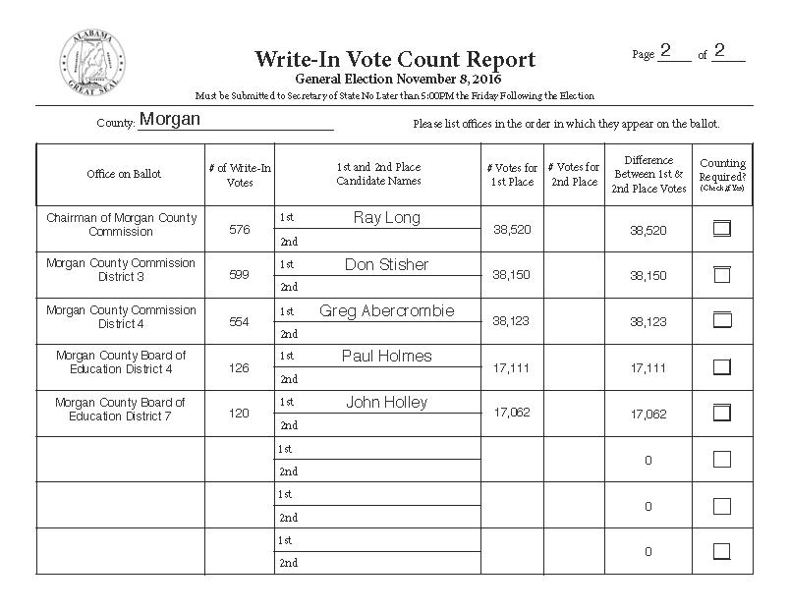

Ana Franklin Sheriff Date

Chris Priest Circuit Clerk Date

Greg Cain Judge of Probate Date

